**Sprint Goal:** Work on save state and account handling. Also work on minor ui fixes and additions.

**Spikes:**

* Spike 1: Login Authentication
* Spike 2: Community Posting

**User story tasks:**

* **User Story 1** **(account)**: As a user I want to be able to create and log into an account so that I can use my saved data.
  + Create account database function (2 hour)
  + Log into account database function (3 hour)
  + API routing to database (3 hour)
  + Security tokens / maybe session ids (2 hour)
  + API schema (2 hour)
  + UI (2 hour)
  + Total: 14 hours
* **User story 2 (color_picker):** As a user I want to be able to choose colors to draw state with so that I make a more custom creation.
  + Find suitable UI component from a library (less than 1 hour)
  + Integrate colors in react states (2 hour)
  + Maintain colors/states with graphical representation (1 hour)
  + Total: 3 hours
* **User story 3 (properties_UI)**: As a user I want to be able to interact with a UI for selecting properties for Cellular Automata so that I can further create my own Cellular Automata.
  + Create input slider for properties values (2 hour)
  + Create UI component for shaderlang parameters (2 hour)
  + Integrate selected parameters in shaderlang and p5 sketch (2 hour)
  + Total: 6 hours
* **User story 4 (community_page):** As a user I want to view posts about user-created CA so that I can see what others have created on the site.
  + Basic function of listview - will improve in Sprint 4 (2 hours)
  + Will follow social media aesthetic with:
    - Name of Post
    - Creator name
    - Link to CA
  + Total: 2 hours
* **User story 5 (error_message)**: As a developer, I want to be able to see an easy-to-understand error message in the UI so that I can diagnose issues.
  + Use Snackbar to show Alert message (1 hour)
  + Export as component so others can use
  + Total: 1 hour

**Tasks:**

1. State saving
2. Fix security vulnerabilities
3. Create a signup page
4. Create a login page
5. Create a community page
6. Fix out-of-bounds drawing bug

**Team Roles:**

Kevin Schultz: Product Owner

Ethan Foster: Team Member

Preston Nguyen: Team Member

Alexander Garza: Scrum Master

Beckett Avary: Team Member

**Initial Task Assignment:**

Kevin Schultz:

* API routing for login and register

Ethan Foster:

* Testing database and fixing security issues

Preston Nguyen:

* Improve Home Page
* About Page
* Get started on Community Page UI elements

Alexander Garza:

* Community page interaction with backend

Beckett Avary:

* Create graphical representation of saved colors/states

**Burnup chart:**

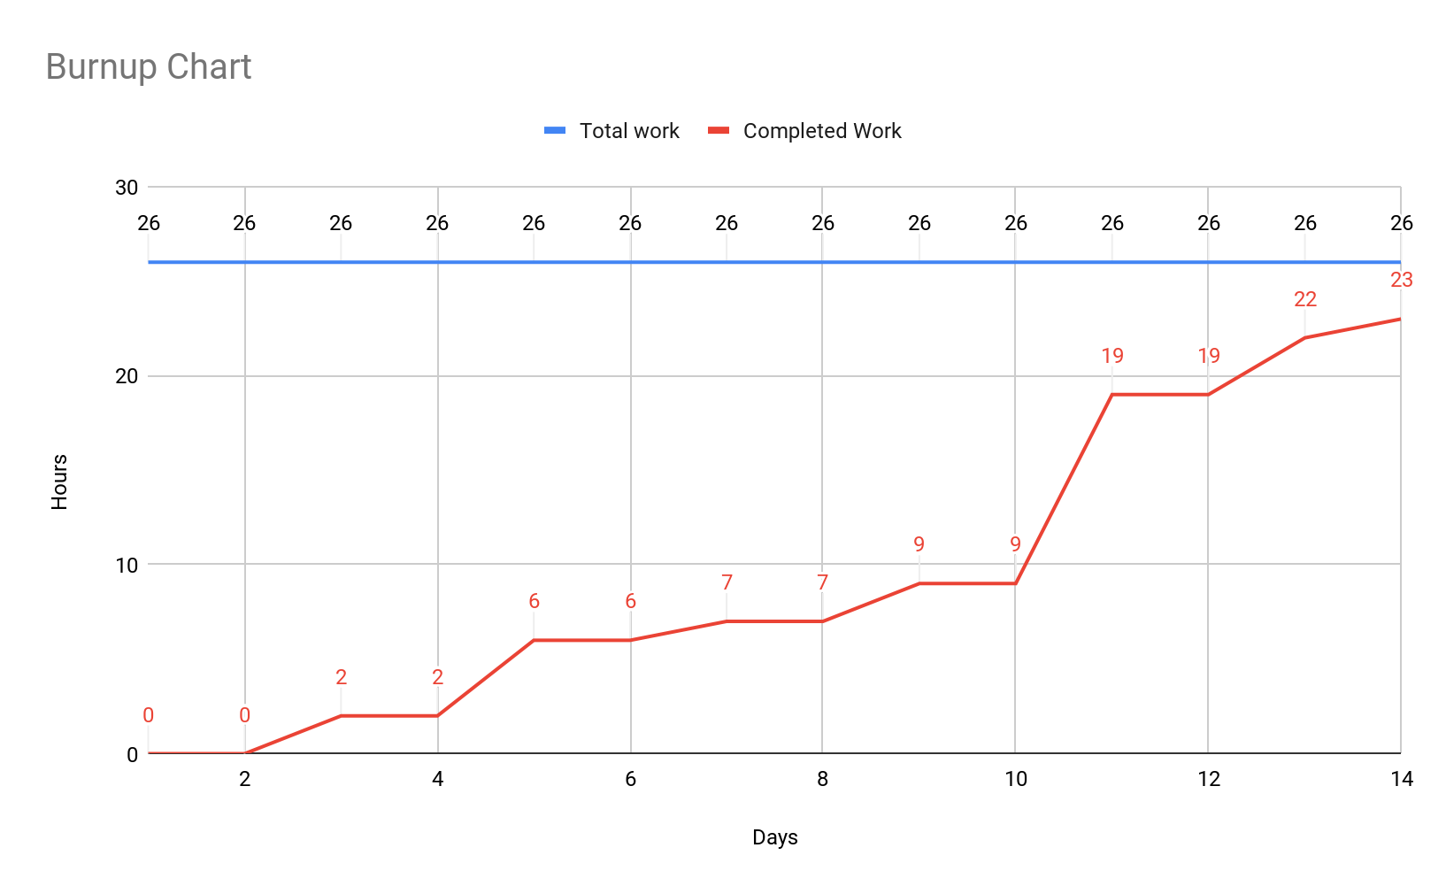

**Prioritize user stories:**

1. save_state
2. accounts/community
3. Properties UI
4. Color picker
5. Error message

**Backlog**

1. Fullscreen

**Scrum Board:**

<https://jamboard.google.com/d/1WuecReEvjC3s1jhugJyICtRss0PQq9s4udIiGU8Cr9I/edit?usp=sharing>

**Scrum meeting times:**

Mon: 3:00

Wed: 4:00

Fri: 3:00